

NOVAC TECHNOLOGY SOLUTIONS

User Manual

Document Version No.: 1.00

Revision History
Version No | Reason For Changes | Author | Approver
0.01 | Draft | Vinothini S
1.00 | Reviewed & Approved the User Manual | Vinothini S | NIJANTHAN PL

Table of Contents
1. Introduction 4
2. CGL Proposal & Policy Generation 4

Introduction

The document is prepared to understand and build an application for Comprehensive General Liability Insurance to the insured..

CGL Proposal & Policy Generation

The scope of the application is to perform the following.
- Collection and recording of insured details through RFQ screen.
- Collection and recording of the subject matter of insurance i.e. CGL – Comprehensive General Liability Insurance policy related information and related Structure needs to be covered.
- Assessing and accepting the sum-insured amount for the required coverage.
- To calculate and display the premium against the sum insured.
- Proposal generation based on the inputted data.
- To accept the payment credentials based on the Proposal generated.
- To accept and account the premium receipted and generate policy.
- Post generating the Policy in the NOVA Application, the user will be allowed to do the endorsement for the Policy. For doing the Endorsement, the user will be provided access for the respective menu by the Admin user
- Endorsement request will be raised by the Branch user and it will be approved by the HO User
- Post Approval by the HO Users, the Endorsement schedule can be downloaded by the Branch user as well as by the HO Users
- For an endorsement, there will be Endorsement Head and Endorsement sub head. Each Endorsement sub head will be mapped to the Endorsement head for doing the Endorsement
- If the user request for an endorsement, the user will be allowed to do so by raising only one request at a time. Post approval of the request another endorsement request will be raised in the system
- User will not be allowed to select multiple Endorsement head (or) Endorsement sub head for one endorsement request.

Path: CGL -> CGL Proposal Dashboard
Screen Code: S0554

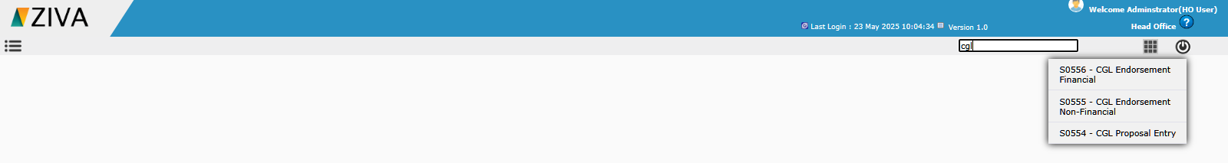

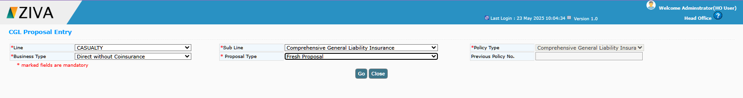
After selecting the sub Line and policy type details, on clicking Go button, remaining fields to capture the proposal details will be displayed.

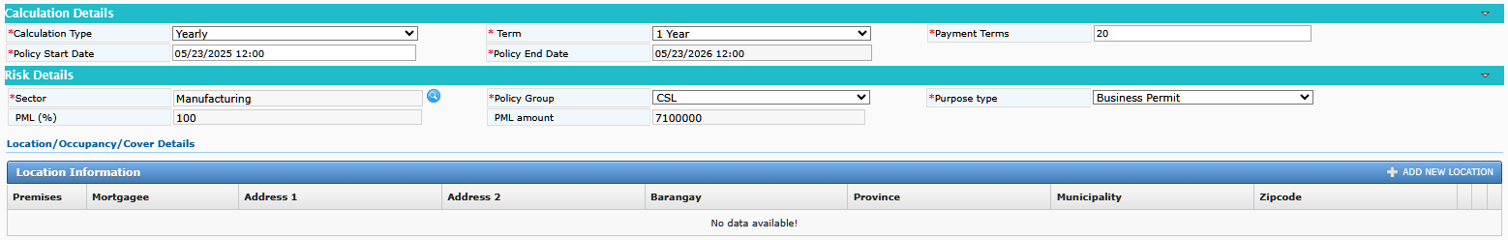
Enter Calculation details , Risk details -> Select Policy Group as CSL, after enter all details click ADD NEW LOCATION in Location information tab.

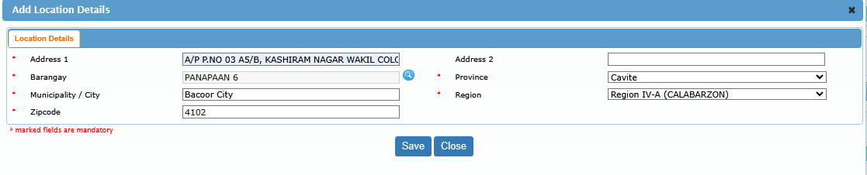
On clicking Save button, system add the new Location.
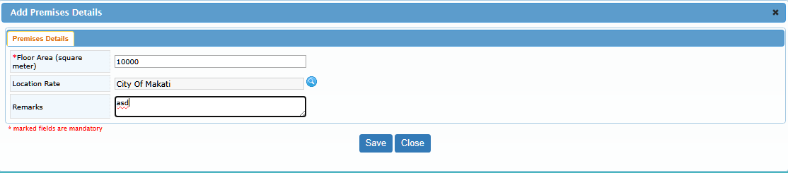

On clicking Save button, system add the Floor area in Premises details. Then enter the SMI and cover details for the respective location.

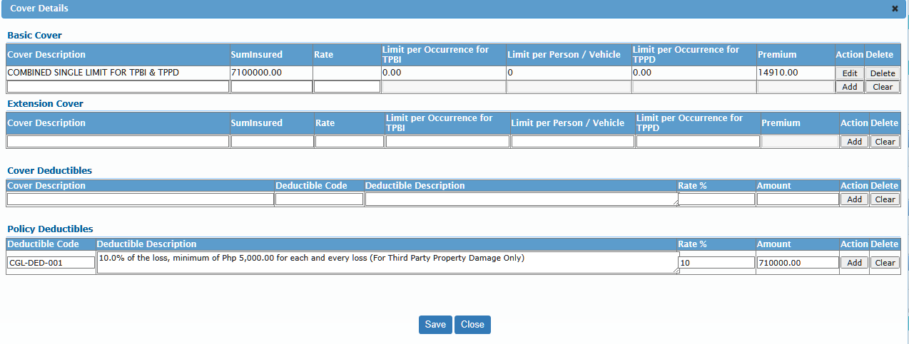
User can able to add the Mortgagee details for the location by clicking the mortgagee icon.

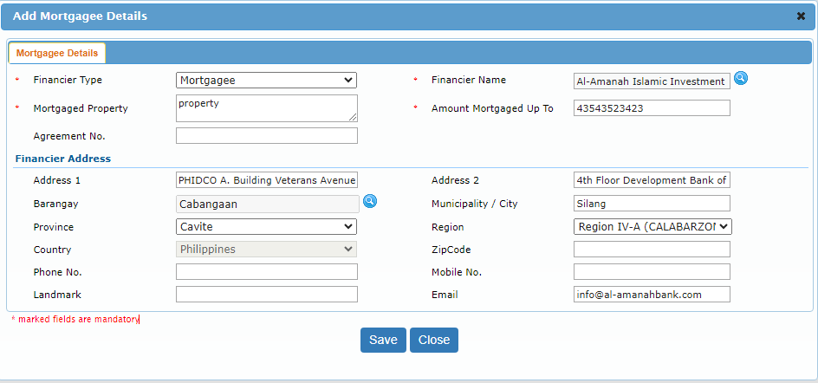

After entering all the details and click on calculate premium user can generate a Quote and then covert a proposal and generate a CGL policy.

